Arrays
1. Acknowledgement
This repository and the following documentation were created with guidance from various programming resources and textbooks on data structures and algorithms. Special thanks to the contributors and educators who have provided invaluable resources and insights into array data structures.

2. List of Contents
- About Arrays
- Concepts of Arrays
- Array Functions with Code Examples
  - Array Initialization
  - Traversal
  - Insertion
  - Deletion
  - Sorting
  - Searching

3. About Arrays
Arrays are a fundamental data structure used to store a collection of elements of the same type. They provide a way to index and access elements efficiently using an integer index. Arrays are widely used due to their simplicity and performance benefits, especially when dealing with fixed-size collections.

Key Characteristics of Arrays:
- Fixed Size: The size of an array is determined when it is created and cannot be changed dynamically.
- Indexed Access: Elements can be accessed directly using their index, providing constant-time access.
- Homogeneous: All elements in an array are of the same type.
- Contiguous Memory Allocation: Elements are stored in contiguous memory locations.

4. Concepts of Arrays

4.1 Array Declaration and Initialization
In Java, arrays can be declared and initialized in various ways:
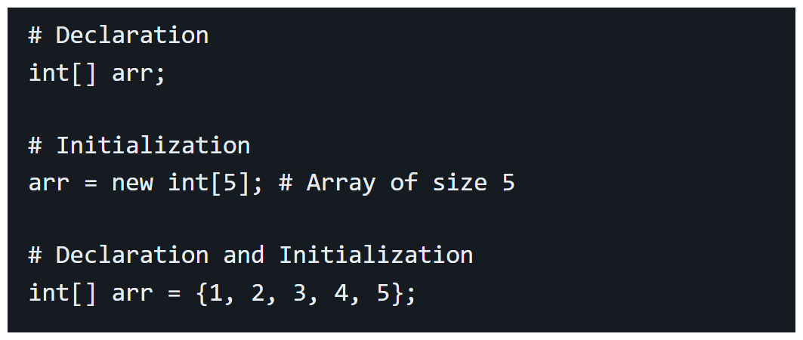

4.2 Array Traversal
Traversal involves visiting each element in an array, usually to perform some operation on it.
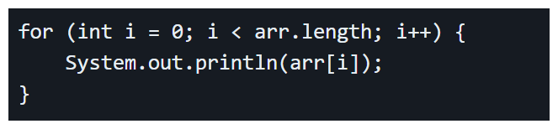

4.3 Array Insertion
Insertion in arrays requires shifting elements to make space for the new element:
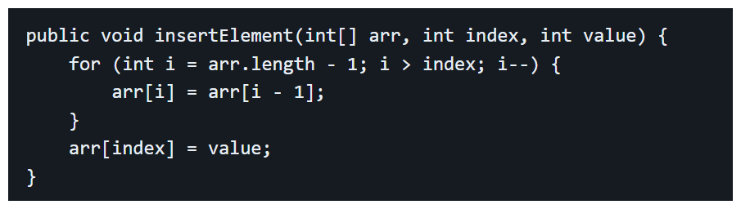

4.4 Array Deletion
Deletion involves removing an element and shifting the remaining elements to fill the gap:
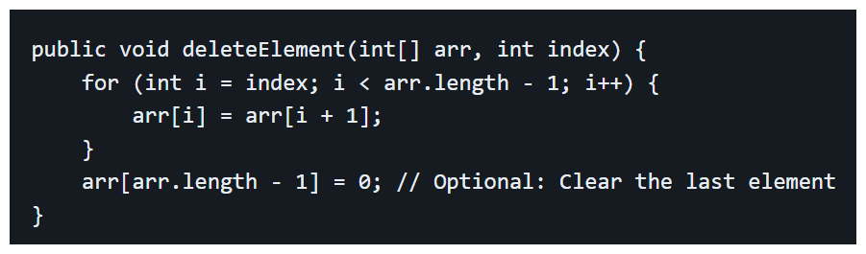

4.5 Array Sorting
Sorting rearranges elements in a specific order, such as ascending or descending:
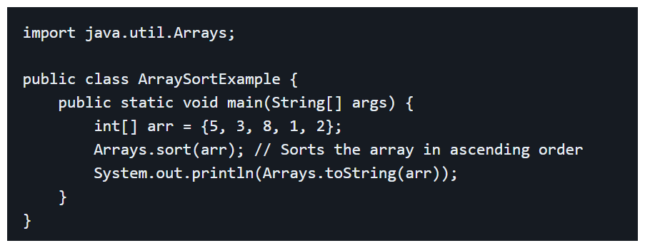

4.6 Array Searching
Searching is used to find a specific element in an array:
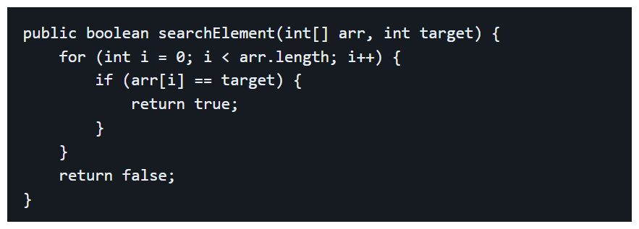

5. Array Functions with Code Examples
5.1 Array Initialization
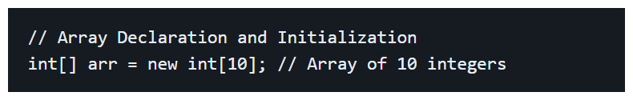
5.2 Array Traversal
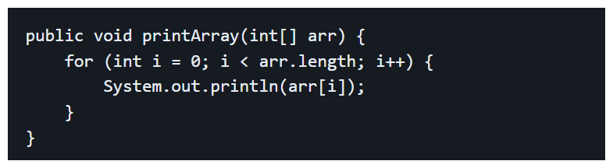
5.3 Array Insertion
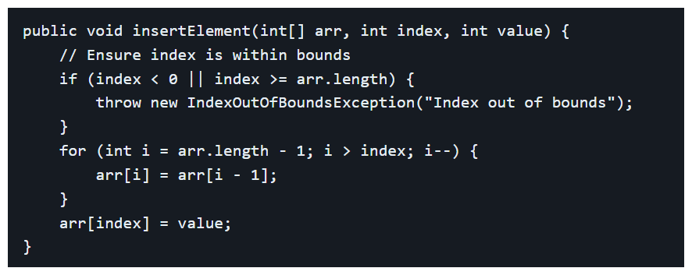
5.4 Array Deletion
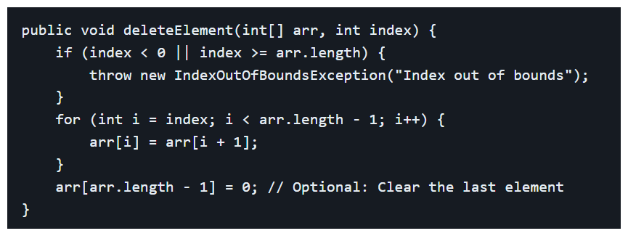

5.5 Array Sorting
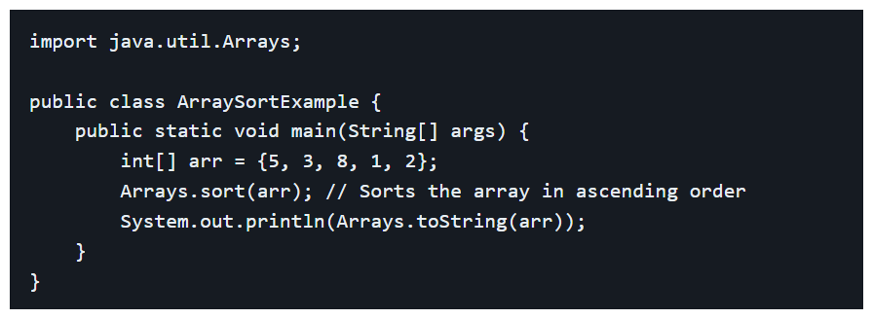
5.6 Array Searching
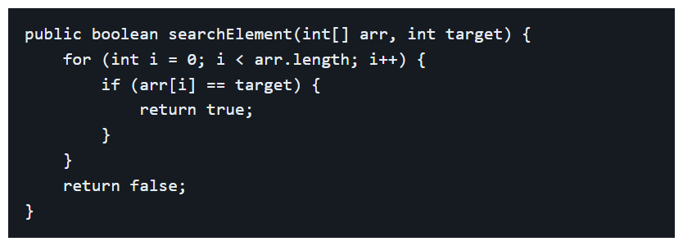

--------------------------****************--------------------------
END
--------------------------****************--------------------------

